Name ______________________________________________

80
YEAR 10 SCIENCE TEST
CHEMISTRY 2013
Part A: Multiple Choice (15 marks)
- The atomic symbol for a gold atom is 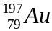. Clarify what this tells you about the gold atom.
- It contains 118 protons.
- It contains a total of 197 protons, neutrons and electrons.
- It contains 118 neutrons.
- It contains 197 electrons.

- A phosphorus atom has an atomic number of 15. State how many electrons it has in its third (outermost) shell.
- 0
- 2
- 5
- 8

- Identify which of the following will cause an atom to become a negative ion.
- gain electrons
- lose protons
- gain neutrons
- lose neutrons

- Identify which of the following statements best describes a particle with 17 protons, 16 neutrons and 18 electrons.
- It is an ion because it has lost an electron.
- It is an atom because it has gained an electron.
- It is an atom that has lost a proton.
- It is an ion because it has gained an electron.

- Which of the following are all transition metals?

(a) Li, Mn, Ca
(b) Mn, Fe, Cu
(c) F, Cl, Br
(d) Na, K, Fe

6. Which of the following are all alkali metals?

(a) Li, Na, K
(b) Mg, Ca, Na
(c) He, Ne, Ar
(d) Cu, F, Mn

7. Which of the following are noble gases?

(a) Ne, Ar, He
(b) He, N, H
(c) O, H, Ar
(d) O, He, Ne

8. The valence electrons are:
(a) the number of total electrons an atom has.
(b) the number of electrons in the atom's outer shell.
(c) the number of electrons an atom has after it reacts.
(d) the number of electrons an atom has before it reacts.

9. The mass number of an element is how many ____________ there are one atom.

(a) protons
(b) electrons
(c) neutrons
(d) protons + neutrons

10. Which line of the table correctly matches the name and description?

 | Element | Description
a | Argon | Noble Gas
b | Beryllium | Non-metal
c | Carbon | Halogen
d | Potassium | In Group 19

11. Consider the following table listing the properties of some elements.

Substance | Properties
I | Shiny, insulator, hard, odourless, brittle
II | Conducts electricity, shiny, yellow
III | Low density, shiny, can be beaten into thin sheets
IV | Does not conduct electricity, shiny, melts at 4000 degrees C
V | Dull, melts at 300 degrees C, brittle

Based only on these observations, which are metals?
- II only
- V only
- II and III
- I and II

12. An atom has two full electron shells. How many electrons does it possess?

  - 8
  - 10
  - 18
  - 32

13. Which of the following statements about metals IS NOT true?

  - They are all good conductors of electricity
  - They are all good conductors of heat
  - They are all solid at room temperature
  - They can all form positive ions.

14. Analyse the word equation:
methane + oxygen → carbon dioxide + water + energy
This reaction shows that:
A oxygen is a product of this reaction.
B methane is both a product and a reactant.
C water is a product of this reaction.
D carbon dioxide is a reactant in this reaction.

15. The Law of Conservation of Mass states that ‘During a chemical reaction, atoms are neither created nor
destroyed’. This law suggests that if a chemical reaction occurred inside a closed container, the total mass of the container and its contents would:
A increase as more chemicals are produced by the reaction.
B decrease if the chemical reaction produces a gas.
C stay the same.
D increase or decrease depending on the type of chemical reaction.

Part B: Written Response (55 marks)

16. Boron has an atomic number of 5 and an atomic mass of 10.81

- How many protons, electrons and neutrons does it have? (3 marks)

Protons ___________ Electrons ____________ Neutrons ____________

- Draw one boron atom. Provide a key to identify the parts listed above. (3 marks)

- Use an arrow to mark the position of the nucleus. (1 mark)

- Draw a line joining the subatomic particle with its electric charge. (3 marks)

Proton Electron Neutron

Neutral Positive Negative

17. Complete the following table: (6 marks)

Atomic structure | Na  23  11 | B  1123  5
Element
No. of protons
No. of electrons
No. of neutrons
Atomic number
Mass number

18. Choose from the words in the box to accurately complete the sentences below.
(2 marks)

metals gain lose non-metals

Elements that become positive ions do so because their atoms ___________________ electrons. ___________________ typically become positive ions. Elements that become negative ions do so because they have a tendency to ___________________ electrons. ___________________ typically become negative ions.

19. A student draws the diagram below to represent the electron configuration of a neutral atom. (2 marks)
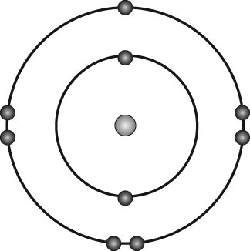

a What is the name of the element?
__________________________________________________________________

b Write the electron configuration for the element.
__________________________________________________________________

20. Complete the table below, describing the type and number of each atom in the molecules listed.

Molecule | Type and number of each atom present
e.g H₂O | 2 Hydrogen atoms 1 Oxygen atom
CO₂
KMnO₄
(5 marks)

21. Draw the electron configurations for the following. Remember to write the number of protons and neutrons and use X’s to show the electrons. (6 marks)
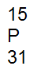
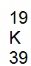
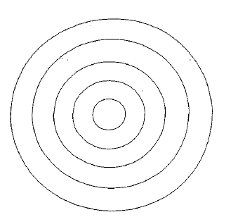

22. From the table below, identify the following species: (4 marks)

  - Neutral Atoms _____________________________

  - Positive Ions _____________________________

  - Negative Ions _____________________________

Species | Protons | Electrons | Neutrons
A | 20 | 18 | 20
B | 17 | 18 | 18
C | 19 | 18 | 20
D | 18 | 18 | 22

23. Complete the following table: (6 marks)

Symbol | Name of atom | Electron configuration | Periodic table group
 | Lithium
 | Silicon
 |  | 2, 6
 |  | 2, 8, 8, 2

24. Write the formula for these compounds: (5 marks)
- Sodium chloride ________________________________________
- Aluminium fluoride _____________________________________
- Calcium oxide ___________________________________________
- Magnesium nitride _____________________________________
- Lithium sulphide _______________________________________

- When sodium metal and chlorine gas react, sodium chloride is produced. (6 marks)
- Name the reactant/s:
________________________________________________________________________________
- Name the products/s:
________________________________________________________________________________
- Write the word equation for this reaction:
________________________________________________________________________________
- What does the arrow (→) mean in a chemical equation?
_________________________________________________________________________________

- Balance the following chemical equations: (3 marks)
  - _____ H₂O → ______ H₂ + ______ O₂
  - _____ Mg + ______ HCl → ______H₂ + ______ MgCl₂
  - _____ CH₄ + _______ O₂ → _______ H₂O + _______ CO₂

27. a) Fill in the families on the periodic table using the ones listed below. (6 marks)
Alkali metals, Alkaline earth metals, Nobel gases, Transition metals, Halogen gases, Rare earth metals.
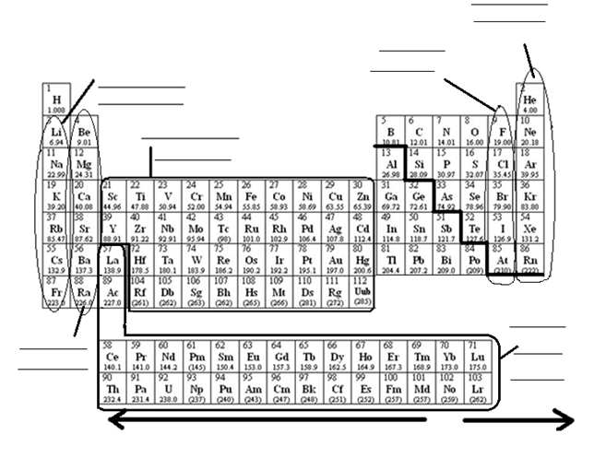

b) Look at the diagonal line, the elements touching this line have special characteristics – what is the name given to these elements?
_________________________________________________________ (1 mark)
c) Look at the arrows on the bottom of the periodic table. On which side would you find the metals? Left or right.
___________________________________________________________ (1 mark)

d) What are the rows of the periodic table called? ________________________________ (1 mark)

e) What are the columns of the periodic table called? ________________________________ (1 mark)

